There are only 6 HTML pages created so far:

The strict at the end of the file names, was because they are XHTML 1.0 Strict

compliant, as the original files were using traditional HTML validation.

**SignupStrict.html**

The index page of the site currently. All fields listed are required in the

database for the user, and is meant to allow the user to sign up quick and easily.

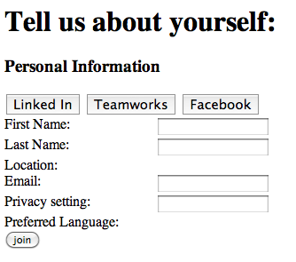

1. Clicking on Join validates the data in the form and if it is not valid, reloads this page again. Need to make errors show on the form.
2. Clicking on Linked in opens up the template importLinkedIn.html as a javascript popup
3. Clicking on Teamworks opens up the template Teamworks as a javascript popup
4. Clicking on Facebook opens up the template facebook as a javascript popup

**HomepageStrict.html**

The page that users would see when they log into a site normally where they

don't need to sign up.

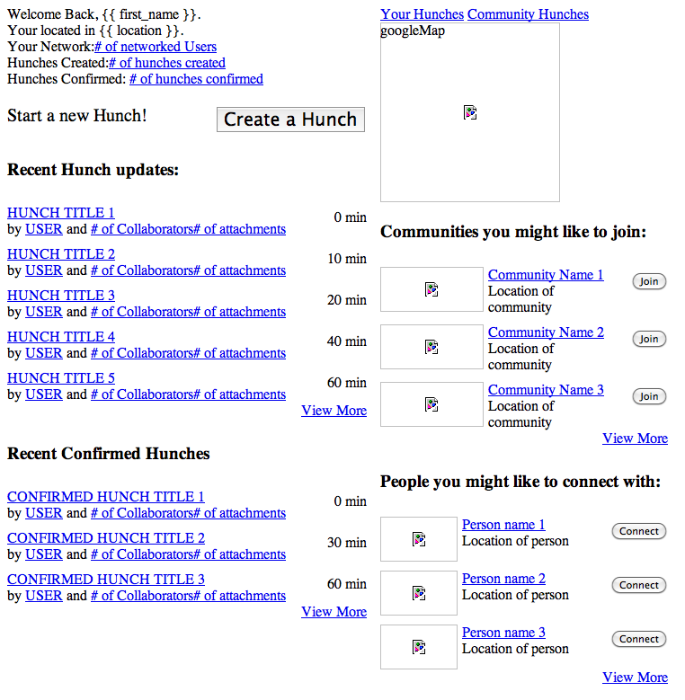

None of the buttons or links link to anything that is built. Page has been changed by design team, so changes need to be made to HTML.

**ProfileStrict.html**

The page that would be the user's profile. User is directed to this page after

finishing the signup page currently.

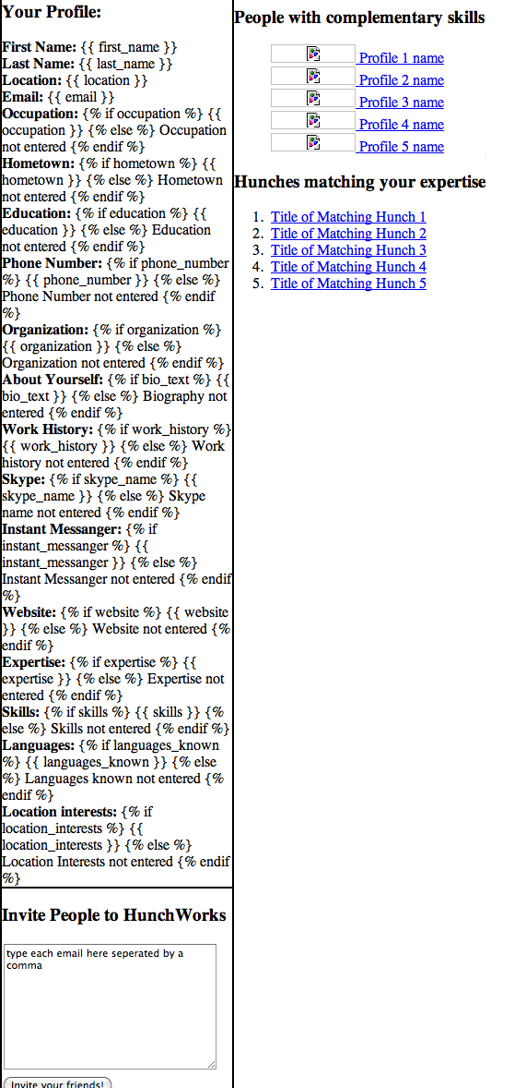

None of the links currently link to anything that is built. Some minor redesign needed on profile information shown as it has changed since template built.

**importLinkedIn.html**

a popup created using javascript. Do not know how to do this with python.

Does not pass anything back to the hunchworks program at the moment.

Leah currently building the functions for this.

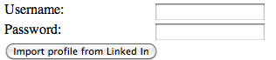

Clicking the button currently doesn’t do anything.

**importFacebook.html**

a popup created using javascript. Do not know how to do this with python.

Does not pass anything back to the hunchworks program at the moment.

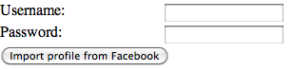

Clicking the button currently doesn’t do anything.

**importTeamWorks.html**

a popup created using javascript. Do not know how to do this with python.

Does not pass anything back to the hunchworks program at the moment.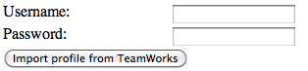

Clicking the button currently doesn’t do anything.